**Problem 5 : Quiz Application**

**AIM:**

Develop a Quiz Application using JavaScript

**PROGRAM CODE:**

|  |  |
| --- | --- |
| Index.html | <html>  <body>  <div style="background-color: bisque">  <h1 align="center">QUIZ MASTER</h1>  <div>  <b>1. PHP is used for</b>  <br>  <input type="radio" name="q1" value="1">Client side<br>  <input type="radio" name="q1" value="2">Server side<br>  <input type="radio" name="q1" value="3">Styling<br>  <input type="radio" name="q1" value="4">Traffic monitoring<br><br>  <b>2. Who invented C language</b>  <br>  <input type="radio" name="q2" value="1">Steve Jobs<br>  <input type="radio" name="q2" value="2">Bill Gates<br>  <input type="radio" name="q2" value="3">James Gosling<br>  <input type="radio" name="q2" value="4">Dennis Ritchie<br>  <br>  <b>3. Google is a </b>  <br>  <input type="radio" name="q3" value="1">Gaming site<br>  <input type="radio" name="q3" value="2">Accounting software<br>  <input type="radio" name="q3" value="3">Search engine<br>  <input type="radio" name="q3" value="4">Smart watch<br>  <br>  <b>4. Who is known as the father of modern computing</b>  <br>  <input type="radio" name="q4" value="1">Mark Zuckerburg<br>  <input type="radio" name="q4" value="2">Bill Gates<br>  <input type="radio" name="q4" value="3">Alan Turing<br>  <input type="radio" name="q4" value="4">Charles Babbage<br>  <br>  <b>5. Facebook is used for</b>  <br>  <input type="radio" name="q5" value="1">Mathematical calculations<br>  <input type="radio" name="q5" value="2">Communication<br>  <input type="radio" name="q5" value="3">Drawing pictures<br>  <input type="radio" name="q5" value="4">Video creation<br>  <input type="submit" onclick="fun()" value="Submit">  <br>  <h4>Your score:</h4><p id="dis" style="color:red"></p>  <script type="text/javascript">  function fun()  {  var a  var c=0  a=[document.getElementsByName("q1"),document.getElementsByName("q2"),document.getElementsByName("q3"),document.getElementsByName("q4"),document.getElementsByName("q5")]  if(a[0][1].checked)  {  c=c+1  }  if(a[1][3].checked)  {  c=c+1  }  if(a[2][2].checked)  {  c=c+1  }  if(a[3][2].checked)  {  c=c+1  }  if(a[4][1].checked)  {  c=c+1  }  document.getElementById("dis").innerHTML=c  }  </script>  </div>  </div>  </body>  </html> |

**RESULT**

These are the output display of pages that are specified in the aim of the program

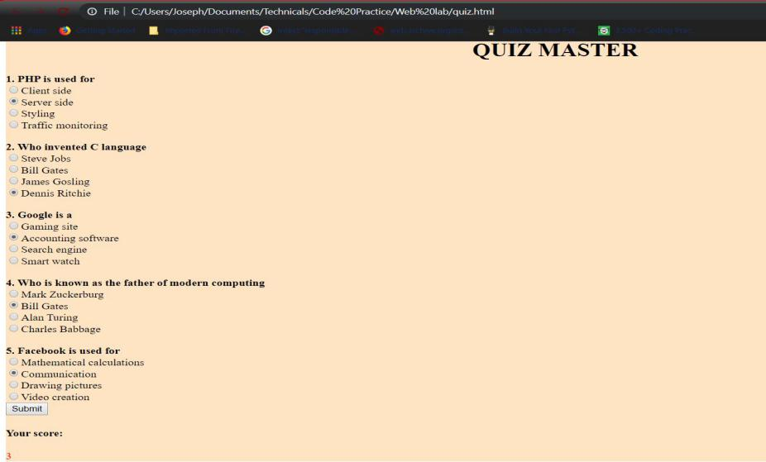

Figure 1: index.html